Annual Programme

The Society has a wide range of activities for members throughout the year. Annual Subscription: Adult standard £20 or Full time Student £10
What membership offers you:-
FIELD WORK: Members participate in field-walking, geo-physical surveys, excavating, finds processing, etc. Join the "diggers" for active archaeological research, training is given.
ARCHAEOLOGY LECTURES: During the winter, illustrated lectures are given by specialists on a wide range of archaeological and historical subjects, with particular focus on local and regional topics. Archaeology lectures in central Brighton.
LOCAL HISTORY FORUM: Presents monthly talks in winter on historical topics of mainly local interest, also seminars, and summer walkabouts. Local History lectures in central Hove.
DAY SCHOOLS: Tuition from experts on archaeological finds, fieldwork techniques, and interpreting the past, 2 or 3 times a year. (Additional fees apply.)
EXCURSIONS: Walks and excursions take place during Summer.
PUBLICATIONS: The Society's newsletter "FLINT” appears half-yearly.
Email Updates: Weekly updates by email. Everything you need to know about what’s on in the Society plus information about archaeology-related events locally.

AFFILIATIONS:
Sussex Archaeological Society
Council for British Archaeology (S.E. Regional Group)
REGISTERED CHARITY No. 206372

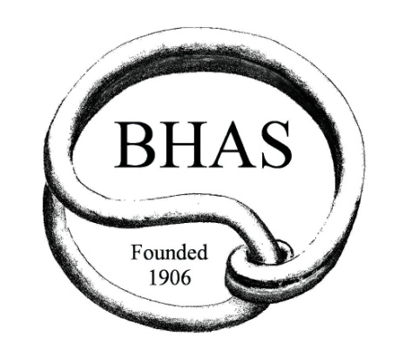

Brighton and Hove
Archaeological Society
Inaugurated 1906

*

Archaeology Lectures

Local History Lectures

Field Work including Excavations

Training

Publications

*

www.brightonarch.org.uk

information@brightonarch.org.uk

The BHAS membership year runs from October 1st to September 30th

Membership Application

I wish to join Brighton & Hove Archaeological Society.

My annual subscription is (please select)
….… £20 (standard adult) ……£10 (full-time student)
See below for how to pay

Name…………………………………………………………….......……

Address……………………………………………………….........………

…………………………………………………………...........………….…..

Post Code ………………………….Tel.No:……………………………

E-mail ……………………………………………………………………..….

Signature……………………………… Date ……………..……

How to pay your subscription:

Direct transfer to our bank: –
Email your completed application form to the Membership Secretary: Membership@brightonarch.org.uk. You will then receive the BHAS bank details.

Cash, or cheque payable to “BHAS”: –
Email your completed application form to Membership@brightonarch.org.uk. You will then be contacted about how to send cash or cheque.

No email? No problem.
Phone or text membership secretary Delia Cattell on 07751 039442 to arrange postal or in-person transaction.

Do you wish to receive BHAS weekly email news updates?
….…Yes …… No

Are you willing to receive FLINT and Society AGM reports etc. by email, thus reducing our postage and printing costs?
……Yes …… No

How did you hear about BHAS / become interested in joining us? ……Word of mouth
……Internet search
……Social Media (which?......................
……At an event (which?)…………………. ……Other: ………………

Which of our activities particularly appeal to you?
….. Archaeology Lectures
….. Local History Lectures
….. Field work including Excavating and Surveying
….. Finds Processing and Recording
……Excursions and Site Visits
….. Walks
….. Day Schools
….. Outreach activities

Is there anything else you would particularly like to get from your membership?

Do you have specific skills or knowledge (e.g. in Computing, Advertising, First Aid, Social Media, Fund Raising) you would like to bring to the Society?

BHAS Membership Secretary Delia Cattell:-
Email membership@brightonarch.org.uk Phone/text 07751 039442

N.B. If you would like to pay future subscriptions by Standing Order, please tick here and a S.O. form will be sent for you to give to your bank ……….

Data Protection: We always respect your privacy. Your details are held for membership purposes only and never shared with anyone else.
1 October 2024

